CSCE606 Software Engineering Final Report

Outsourcing Network Assessment Tool (ONSAT)

Contact: Dr. Daniel Ragsdale

Texas A&M Cybersecurity Center

Team: HowdyCoders

**Team Members:**

Edward Mondragon

Eikagra Sharma

Chengyi Min

Hyundeok Park

Gerald Hu

Jee Su Byun

Shaolong Chen

**Table of Contents**

**Introduction** **3**

**Summary of the project** **3**

**User stories and Lo-fi UI** **3**

**Description of user stories and Lo-fi UI** **3**

**Role of each Iteration** **6**

**Overview** **6**

**Description of each iteration** **6**

**Customer Meeting details** **7**

**BDD & TDD process** **7**

**Configuration management approach** **7**

**Issues using Heroku and AWS** **8**

**Miscellaneous** **8**

# Introduction

## Summary of the project

The purpose of the ONSAT project is to migrate the evaluation tools managed by a spreadsheet to web-based tools. The tools’ purpose is to evaluate which companies would be best to outsource network services to. The tool helps stakeholders make decisions by charting the Trustworthiness, Security, and Financial scores of the evaluated company. All the functions supported by the Excel file are implemented in the same way. In addition, the function of validating each item improves the completeness of the tool.

The stakeholders of this project are the U.S. government agencies. According to the stakeholder requirements, the functions are divided into home, input, output, formula, and scenario tabs. The input method supports csv input method and manual typing method and provides collapsible view by category. Once the input completes, the result displays the results in the output tab and change any additional values by each users’ role.

# User stories and Lo-fi UI

## Description of user stories and Lo-fi UI

|  |  |
| --- | --- |
| **Feature: Universal Navigation Bar (3 pts)**  As a user  While using website  I want to go to different pages  Scenario: Questions page shown  Given I am on the Home page  When I follow "Input"  Then I should see "All Questions"    Scenario: Home page shown  Given I am on the questions page  When I follow "Home"  Then I should see "home page"    Scenario: Output page shown  Given I am on the questions page  When I follow "Output"  Then I should see "output page"    Scenario: Formulae page shown  Given I am on the questions page  When I follow "Formulae"  Then I should see "formulae tab" | https://lh4.googleusercontent.com/gSvjevEuhMwGtjW99scKApo2MRXVg-qw-Nly2SsYZwZKgQGOKbFNtIs-GHxpyMkVlQjcvDV9mfb7nTlEr5V6D4BBMpzFHIIr5eFGwIcxErrg6R1Pzzd_f-WanoSdIzvTbjV4iqPy |

|  |  |
| --- | --- |
| **Feature: Check each category formula (1pts)**  As an admin  I should be able to see formula  Scenario: Click collapsible each category and subcategory  Given I am on the formula page  And I can see the formula information  As an general user  I should be able to see formula  Scenario: Click collapsible each category and subcategory  Given I am on the formula page  And I can see the formula information  As an decision maker  I should be able to see formula  Scenario: Click collapsible each category and subcategory  Given I am on the formula page  And I can see the formula information | https://lh3.googleusercontent.com/8tlqtY2-bVGC6i-ismVDB2uPvZGFtouG2d83vztAtTM6JP6c3rh32DzbkA-uPR2qfGOHFxbuHsC7tP7w7ZzH6zbG9O4tnjjgniVdoSBMvd3dayQ7DpZmJN-c5dAmDS8M_mLnm6n2 |

|  |  |
| --- | --- |
| **Feature: Validating each item (2 pts)**  As an admin or decision maker  I should be able to validate each item that company answered  Scenario:  Given I am on the input page  I am able to validate the items  **Changes:** Transferred to validator  **Feature: Submitting answers(3 pts)**  As a user of the system  I should be able to submit answers to the system  Scenario: Submit answers filled in dropdowns  Given I am on the input page  And I filled out some answers  And I click the submit button  Then my answers should be stored | https://lh4.googleusercontent.com/gSvjevEuhMwGtjW99scKApo2MRXVg-qw-Nly2SsYZwZKgQGOKbFNtIs-GHxpyMkVlQjcvDV9mfb7nTlEr5V6D4BBMpzFHIIr5eFGwIcxErrg6R1Pzzd_f-WanoSdIzvTbjV4iqPy |

|  |  |
| --- | --- |
| **Feature: Inspecting Final Decision Scores (3 pts)**  As an admin or decision maker  I should be able to see the final scores of certain scenarios  Scenario: Inspecting the score of a pack of courses of actions  Given I am on the output page  And I should see courses of actions  And I click on one of them  Then I should see scores on the same page |  |

|  |  |
| --- | --- |
| **Feature:** **Submit file (2 pts)**  As a user of the system  I should be able to upload a csv file to the system  Scenario: Submit an existing form to and display the question list  Given I am on the upload page  And I choose the file and press upload  Then the file should be parsed  And the content is stored in the database and I should see the result  **Change:** The upload page was integrated into the input tab | https://lh5.googleusercontent.com/Pj9BL3ROkO4iS-dVBV0eZAHixF2pSf-gPhaQ4HviqfDVgMNDDlkQgijTLa8jCmHp_ZANePumYwBg0GdT52JTbbC7IVOR8d2TjsRCw6hflk586fStL5qU6f8Tv3GevnXxZysVL5zE |

|  |  |
| --- | --- |
| **Feature: Sign-in three different roles (2 pts)**  As an admin  I should be able to sign-in as an admin  Scenario: Submit ID and Password  Given I am on the input page  And I can see the administration menu  As a decision maker  I should be able to sign-in as a decision maker  Scenario: Submit ID and Password  Given I am on the input page  And I can see the administration menu  As a company (general user)  I should be able to sign-in as a general user  Scenario: Submit ID and Password  Given I am on the input page | https://lh3.googleusercontent.com/bMHoqh3wASv8SqkbNA2Yc1ZewLdyFYLzque6kLF6fS1ZBB_YE0mEWribzSwMZfF0icDz7QP32iISGu0IEvvqsDyILIuk-LZwqM5F8yebvuRbGXXTKWV9bug6eWUS5vCTOpN6aSnR |

|  |  |
| --- | --- |
| **Feature: Collapsible categories and subcategories (3 pts)**  As an admin or decision maker or general users  I should be able to fold or unfold the categories  Scenario: Given I am on the input page  I am able to categories and subcategories the items  **Changes:** Validator has the same access when it was added |  |

|  |  |
| --- | --- |
| **Feature: User can configure scenarios (3 pts)**  As an admin or decision  I should be able to add course of actions  Scenario: Given I am on the scenario page  I am able to input scenarios and change weights |  |

# 

# Role of each Iteration

## Overview

|  |  |
| --- | --- |
| Product owner | *Eikagra Sharma* |
| Scrum master | *Chengyi Min (Iteration 0)* |
| *Edward Mondragon (Iteration 1)* |
| *Hyundeok Park (Iteration 2 ~ 4)* |

## Description of each iteration

|  |  |  |
| --- | --- | --- |
|  | Features | Points |
| Iteration 1 | Implemented drop down for answers | 3 |
| Implemented input methods (CSV, manual) | 2 |
| Iteration 2 | Implemented universal navigation bar | 3 |
| Implemented collapsible view | 3 |
| Iteration 3 | Implemented validating items and answer submission | 5 |
| Implemented formula expressions | 1 |
| Iteration 4 | Implemented sign in three different roles | 2 |
| Implemented extension of validation | 2 |
| Implemented scenario view (course of actions), score calculation and inspection | 6 |

# Customer Meeting details

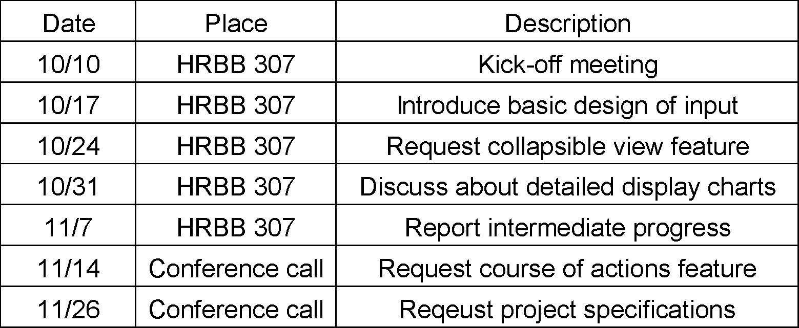

# BDD & TDD process

We used BDD and TDD for the first sprint, to good results. But as the semester went on and our course loads got heavier, we prioritized creating working code over creating tests. Tests take some time to write, and good tests with no code was less valuable than working code with less rigorous testing. This worked okay, since our basic features were not especially complex. However, in retrospect, we would have liked to employ BDD and TDD more rigorously, and humbly admit that taking a more structured approach would have made our project better. This is especially the case for learning how our features interact with each other, and for integration/system testing instead of unit testing. BDD would allow us to model a user’s workflow from start to finish. TDD and automated testing would help us catch holes and edge cases we didn’t think of.

# Configuration management approach

Our configuration management followed a fairly loose approach. Each new feature, update, or fix would get its own branch. Once that feature was complete and tested, its branch was merged back into the master branch. We met regularly to discuss merging multiple branches, in case we ran into merge conflicts that needed to be manually resolved. We did not need spike branches. For the most part, we were able to find the solutions we needed without throwing away any work. Some early on major database changes required corresponding changes to the entire codebase. When a new feature required a new gem, we did research to pick the right gem before starting to code.

# Issues using Heroku and AWS

For the most part, our issues with Heroku and AWS were the same issues we ran into during the homework. The Tutorial posts on Piazza helped alleviate these issues greatly. Since we had heroku deployment in mind at the very beginning of the project, we did not run into much problem in deploying. The whole system does not require heavily on different kinds of third parties, thus the differences between environments work out well most of the time.

# Miscellaneous

We primarily used the Gems provided and discussed in the homework assignments (such as Cucumber). Reusing these gems allowed us to get coding more quickly, since we were already familiar with their basic usage. Cucumber, RSpec, and SimpleCov were used to run test cases and generate test coverage reports. SimpleCov was particularly useful for evaluating how many code paths were tested, especially as our project gained more complexity.

For user authentication, we used the gem Devise. Since Devise came bundled with solutions to handle user registration, accounts, password encryption, etc, we didn’t have to worry about re-inventing the wheel. Integrating Devise into the project was the hard part, since it required rebuilding parts of the database around the Users object.

Gem CSV was used to parse csv files.

For sprint tracking and story assignment, we used Pivotal Tracker to mixed results. We were able to use it effectively for the first few weeks. However, after our Pivotal Tracker free trial accounts ran out, we were unable to change anything in the project. We switched to using Slack for project communication.

* GitHub repo: <https://github.com/howdycoders/ONSAT>
* Vimeo link (Client Previous Interview): <https://vimeo.com/294515063>
* Vimeo link (Client Final Interview): <https://vimeo.com/305632018>
* Vimeo link (Demo): <https://vimeo.com/305643584>
* Pivotal Tracker: <https://www.pivotaltracker.com/n/projects/2204673>
* Heroku: <https://still-wildwood-83026.herokuapp.com>